Budgetwise
Week 10 | 2026-04-17 - 2026-04-24

Leader: Haru Kimura

Sophia  Time Spent  10 hours | Tasks completed:  - Created outline for final presentation and demo  - Need to assign people to a slide  - Need to create video for demo  - Video instead of live presentation to mitigate bugs/issues day of presentation  - Will be video with live voiceover during Teams call  - Worked on the final report  - Created pull request for bank-integrations; Cas merged and should be deployed now  Planned tasks for next week:  - Continue working on final report  - Work on final ppt  - Set up practice time for final presentation with ppt  Any issues or challenges:
Casandra Marquez  Time Spent  11 hours | Tasks completed:  - Resolved issues and merged the bank integration pull request and edits to mail-server  - Created a temporary Gmail account, updated Render backend environment variables, redeployed the service, and tested mail server functionality using a temporary Google account  - Configured a personal Groq API key and verified AI features were functioning properly on Render  - Added Plaid sandbox environment variables to Render and confirmed the integration was working correctly on the deployed application  Planned tasks for next week:  - Keep working on mail server problem  - Work on final presentation and report  - Anything else needed  Any issues or challenges:  - PR conflicts  - Mail server configs causing 500 error
Haru  Kimura  Time Spent  10 hours | Tasks completed:  - Reviewed scalability testing results and identified /api/expenses as a key bottleneck under higher concurrency  - Implemented a scalability optimization for the expenses endpoint by updating the Prisma query to only return the fields used on the frontend (id, amount, category, type, date, note)  - Reduced unnecessary data being sent from the backend which helps improve performance  Planned tasks for next week:  - Work on final presentation and demo video  - Assist with final report and slides  - Help with any last-minute fixes or testing  Any issues or challenges:
Jonathan Strong  10 Hours | Tasks completed:  - Implemented scalability optimization by using caching and avoiding duplicate AI requests  - Currently dashboard has time to live of 1 minute  - AI information has time to live of 5 minutes  - For both it will only replace if a new request comes in after the time to live runs out but will not automatically request  - Tested new optimization to ensure it works in the way wanted  - Successfully avoids unnecessary duplicate calls while swapping between pages  Planned tasks for next week:  - Work on final presentation  - After all changes have been merged into main and deployed re test and compare to previous results  Any issues or challenges:  - Slight merge/docker issues
Marcelo Mejia  Time Spent  10 hours | Tasks completed:  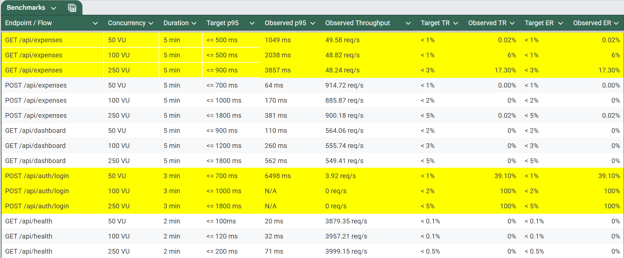  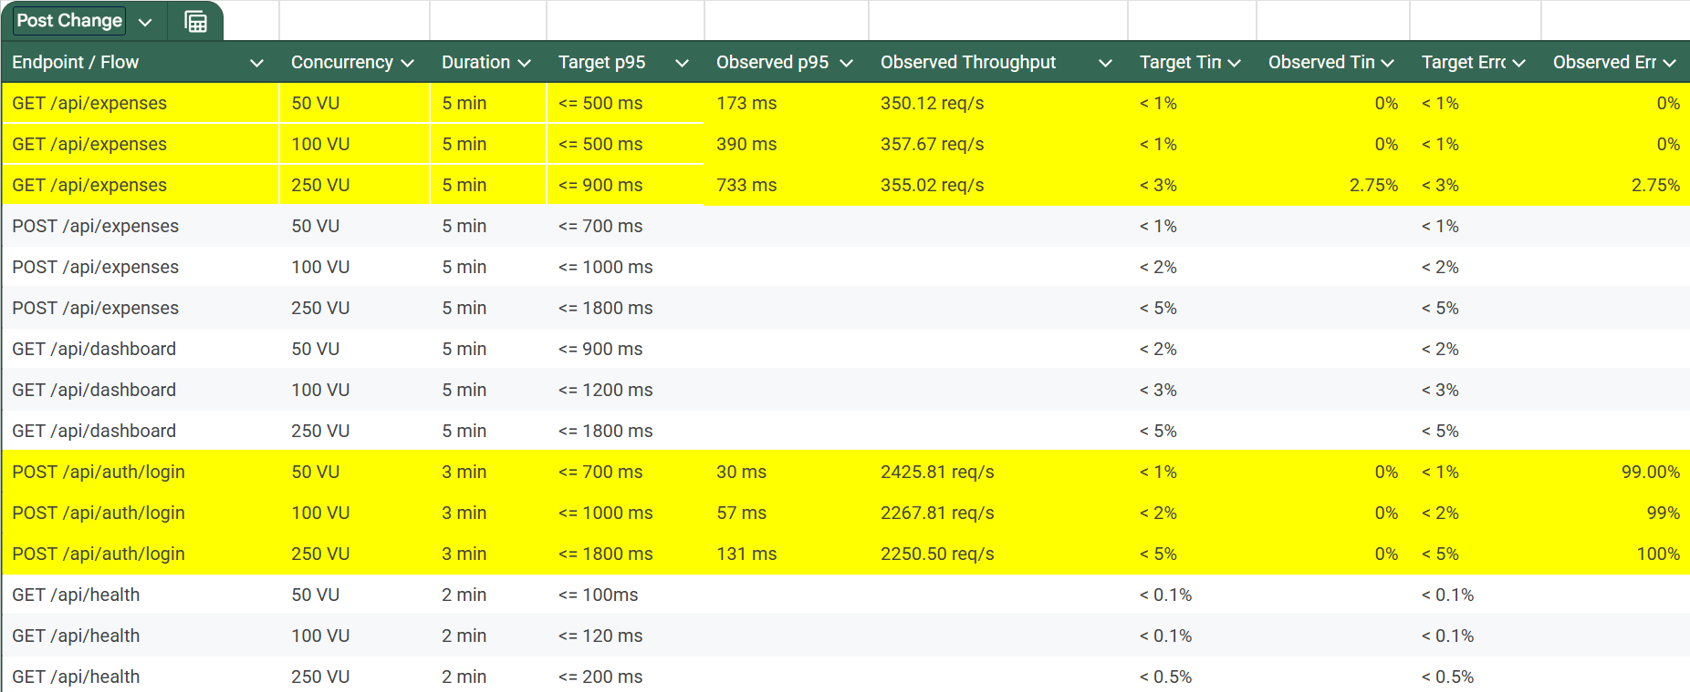  - Added some fixes to app scalability based on testing results from last week (GET expenses and POST login being the main areas of risk):  - Reduced DB pressure by adding pagination and cursor support (instead of one request returning thousands of rows, requests are split into smaller “pages”)  - Added query indexing for common filters, giving a shortcut to requested data rather than having to scan large amounts of info to find the right thing.  - Added a precautionary measure to the login schema where if too many login attempts happen too fast, subsequent requests will be responded with 429 error code (too many requests). This is just to prevent Node/Prisma from being loaded with more than it can handle and issuing timeouts. The core login issue still needs to be addressed.  Planned tasks for next week:  - Look more into how to increase login rates under stress.  - Work on final report + presentation  Any issues or challenges:
Jonathan Gruber  Time Spent  20 hours | Tasks completed:  - Update architecture diagram  - Begin work on final report  Planned tasks for next week:  - Maintain architecture diagram  - Work on final report and presentation  Any issues or challenges:  - No major issues

Total Time Spent:

Summary:

